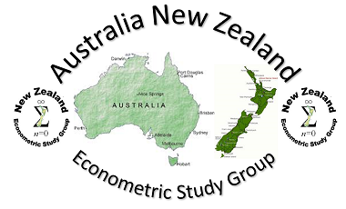

**Australia New Zealand Econometric Study Group**

**2024 Meeting Report**

The 32nd meeting of the Australia New Zealand Econometric Study Group (ANZESG) was hosted with generous support from Motu Research, The Treasury New Zealand and the Reserve Bank of New Zealand, and held at Treasury on Friday 9 February 2024 in Wellington.

What began as NZESG in 1997 has become a regular Trans-Tasman event that provides a supportive environment for econometricians to present and discuss their work. Attendees come from Aotearoa New Zealand, Australia, and further abroad with this year’s attendees coming from England, China, USA and Singapore.

At each event, an emphasis is placed on encouraging and supporting the achievements of emerging researchers who are either PhD students or recent graduates. An award is given to recipients based on their research quality and presentation, and their informed discussion of the research of others.

The Programme Chairs for the 2024 meeting were Peter C.B. Phillips (Yale University), John McDermott (Motu Research) and Jiti Gao (Monash University).

The local organising committee were John McDermott (Executive Director, Motu Research) supported by Christie Smith (Principal Economist, The Treasury), and Hannah Griffin (Executive Assistant, Motu Research) who provided excellent assistance before the meeting and throughout the proceedings.

**The programme and presentations**

The meeting received 24 submissions with the final programme containing 20 papers. These were presented in six sessions over the day with two single-stream sessions, and two groups of concurrent sessions to fit every presentation into one day. The final programme is available on the Motu Research website.

Each participant had 15 minutes to present, there was a five minute discussant session, and the remaining time for was for group questions and discussion.

**32nd ANZESG Young Econometrician Award**

As in previous years, emphasis was placed on encouraging and supporting the achievements of emerging researchers.

Young scholars are eligible for the ANZESG Research Awards funded by the generous support of the Reserve Bank of New Zealand.

Following customary practice, the ANZESG Awards were based on the research paper, the presentation at the meeting, and the quality of candidate discussions of other papers.

Two prizes were awarded at the end of the conference to:

* **Naveed Javed**, from the Reserve Bank of New Zealand

Paper: *Dornbusch’s Overshooting and the Systematic Component of Monetary Policy in SOR-SVARS*

* **Fangzhou Yu**, from the University of New South Wales

Paper: *Tests for Heterogeneous Treatment Effect*

The award winners were noted for their excellent research quality and presentation of their own work, and informed discussion of their own and other’s research.

The organisers received very positive feedback on the event, regarding the organising and location, the programming and thoughtful discussions between all participants and an enjoyable dinner at The Thistle Inn.

The host and timing of the 33rd meeting of the ANZESG has yet to be announced.

**ANZESG 2024 Awards Photos**

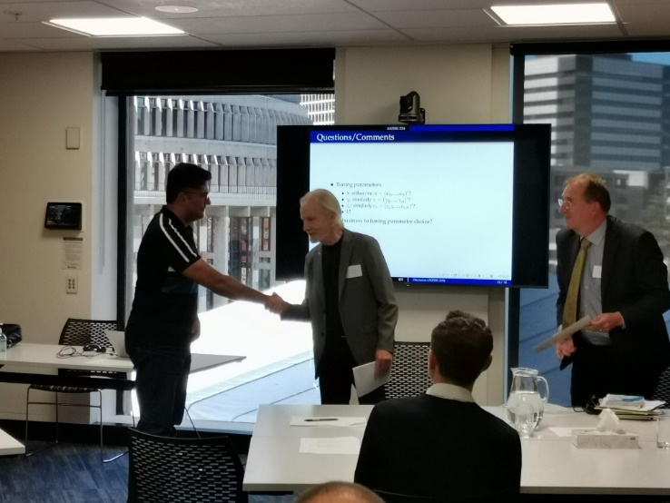

**Naveed Javed** (Reserve Bank of New Zealand) receiving his award from Prof. Peter C.B. Phillips (Yale University).

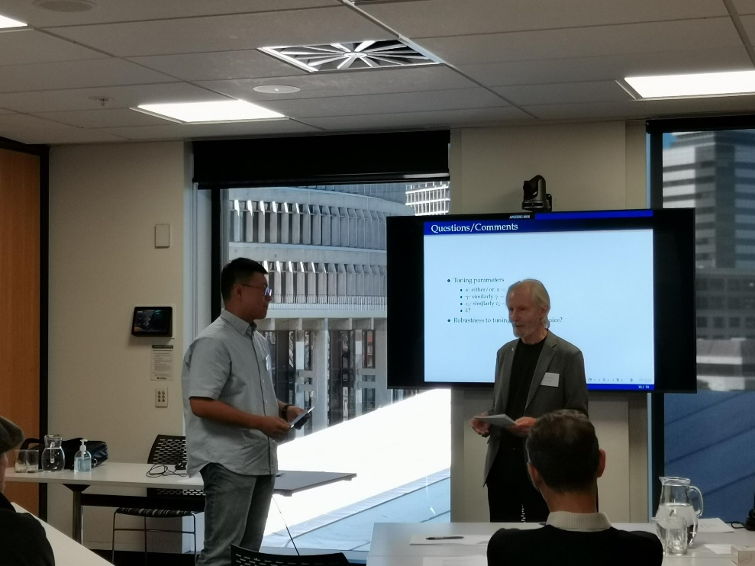

**Fangzhou Yu** (University of New South Wales) receiving his award from Prof. Peter C.B. Phillips (Yale University).